Model View Controller : Model on which is based Angular: “software architectural pattern for implementing user interfaces” (Wikipedia). It is a software pattern for implementing user interfaces. It divides a given software application into three interconnected parts to separate internal representations of information from the ways that information is presented to or accepted from the user. The model, consists of application data, business rules, logic and functions. A view can be any output representation of information (multiple views are possible). The controller, accepts input and converts it to commands for the model or view.
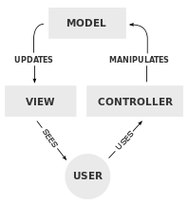
The model is where the data lives. It encompasses all the classes and objects as well as the database. A controller is what is going to react to an input from the client (eg: username & password) and adapt the software behavior accordingly.
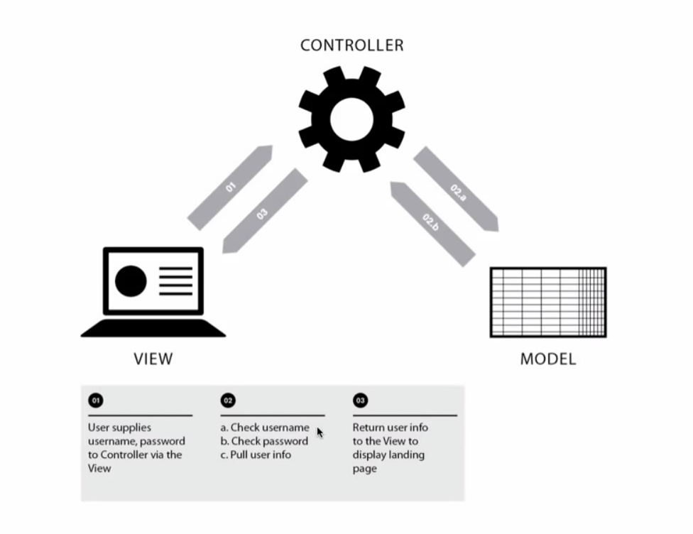
Controller: CEO, he adapts the company output to the market
Model: The dev and R&D team, conceptualize and store the goods.
View: Design team and marketing team, design how the product will be displayed.

Data Binding: Process through which, when the UI is changed, the data will reflect this change (ex: live chat). It often refers to the immediate update of a UI based on input.
Dependency injection: in object-oriented computer programming is a technique that indicates to a part of a program which other parts it can use, i.e. to supply an external dependency (i.e. a reference) to a software component. In technical terms, it is a design pattern that separates behavior from dependency resolution, thus decoupling highly dependent components. Software procedure through which you separate parts of code, so that instead of A saying “I have the power to create an instance of B (eg: the design of the page) and only I have it”, it will refer to a third party script and say “yeaaah, so please create me an instance of B, you know, just put it on my desk, I don’t need to know how you did it.” A doesn’t need to know how B is created; everybody sticks to their scope of action and this makes modifying parts of code safer and easier. A class that creates a service should not be the one that also creates the design, how this service will be displayed to the client. It’s a fancy way of saying: “pass on the dirty work to a dedicated function” For example, In Angular, you inject the data obtained somewhere else (service) into the controller when he needs it. It’s not the controller’s job to go look for the information.
Yeoman is a great tool for developing apps in Javascript.
Controller
Here is, as an example, how a webpage can look with different controllers assigned to different chunks of your view
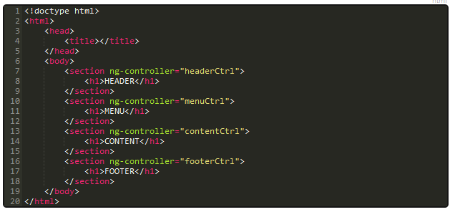
And here is the javascript counterpart
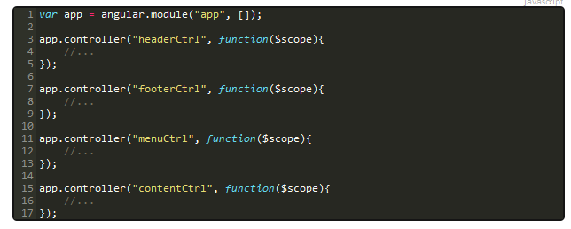
Installing the environment
First you'll need to install nodejs. Once that's done, we recommend you also go for yeoman, composed of three modules :
-bower : is like npm
- yo : will help you set up your project
- grunt : is here to test and run your application
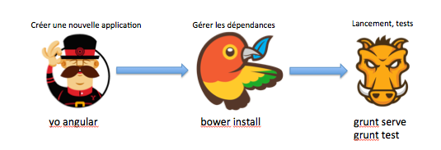

Also, install generator-angular
Setting up a new app
The first command ever you have to enter is :
yo angular
This will prompt a few questions.
Next you will see three files in the main folder that set up the app, two of them being in json.
Package.json lists the info about the packages used for ex :
http://browsenpm.org/package.json
Gruntfile.js establishes the basic testing and compiling processes of the app, as well as server configuration
Resolve unmet dependecies npm
Reinstall all the concerned packages
Data Binding
A controller that tells you wether you are of legal age or not

ng-model sends the value in the input to the variable age in the controllers
ng-bind does kinda the opposite and returns the value in the controller (majeur or mineur) to the tag in the view.

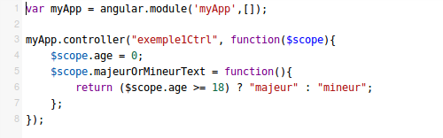

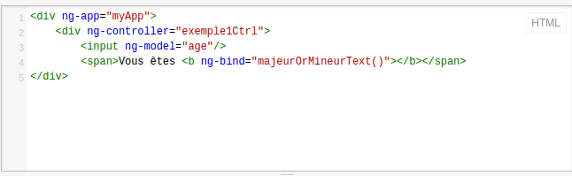

This is how it would look like in jquery
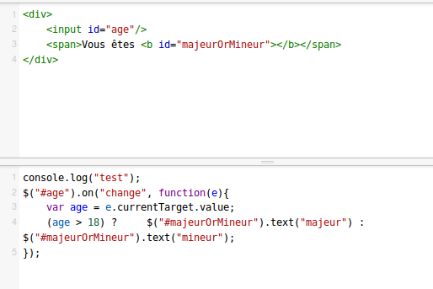
It's bad because this way of doing things modifies the DOM as it updtates, which creates maintenability problems. If you want to change the class , the id of an element you are screwed.
In this version our method is inside a callback, and that makes the test much more complex
« e » is the element
Here you can toggle a content at will without using jquery
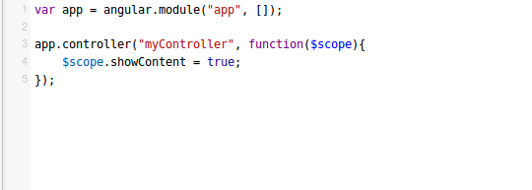

You can see the value of showContent update if the user acts on the view : this is what we call two way data binding. It is an improvement on PHP, which to my knowledge had only one way (from the script to the view)
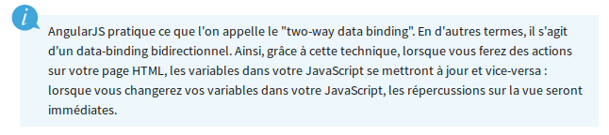

Dependency injection
a module is $scope or $location… The dependency injection is made natively with angular, you just have to specify the module.
For example, any data that is not attached to $scope can not be displayed in the view !
$watch
Sometimes you want your controller to be on the lookout : as the view changes, some data in the controller might change as well !
For example, depending on the amount of goods purchased, you may wanna compute the coupon amount
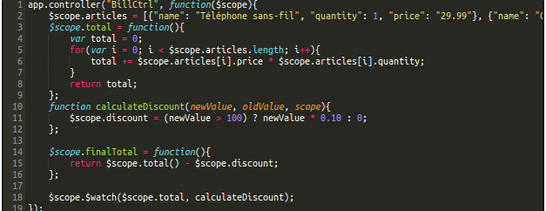
$watch has three paramaters :
(watchFn, watchAction, deepWatch)
watchFn : What property of you controller you wanna keep a close look on (here, the total of purchases)
watchAction : What will be triggered when the property watched changes
deepWatch : put true if you wanna the event to trigger even when only a subcategory is changed inside the whole property.
Downside : this process takes up a lot of memory
The Directives
What we will tackling here is the fascinating world of creating directives :
Make your code do what it is that you want !
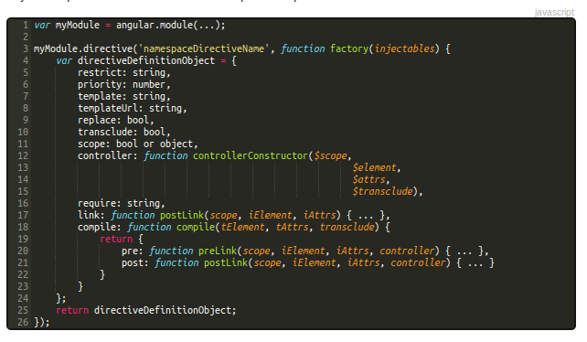
Propriété | Description
restrict  (Optionnel) | Permet de définir comment la déclaration de la directive doit se faire dans le code HTML. Les options sont :  - 'E' pour element. Exemple : <my-loading title="Paramètres">...</my-loading>  - 'A' pour attribut. Exemple : <div my-loading="Paramètres">...</div>  - 'C' pour classe. Exemple : <div class="my-loading:Paramètres">...</div>  - 'M' pour commentaires. Exemple : <!-- directive: my-loading Paramètres -->  La valeur par défaut est 'A'. Il peut parfois être pertinent d'utiliser le 'M', surtout lorsque vous souhaitez ne pas avoir de conteneur dans votre HTML. Croyez-moi, ça arrive!
priority  (Optionnel) | Dans le cas où, sur un même élément, vous auriez plusieurs directives, il est possible d'accorder une priorité à une directive. Les priorités hautes s'exécutent en premier. La valeur par défaut est 0.
templates  (Optionnel) | Permet de remplacer le contenu d'un élément par un template. Cela est par exemple utile lorsque vous développez un système d'onglets. Au lieu d'écrire l'ensemble de votre code au sein d'une seule page HTML dans laquelle vous allez poser tout un ensemble de conditions, vous pouvez juste déclarer un template pour chaque onglet.  Cette option requiert que vous passiez le template de façon "inline", c'est à dire que vous fournissiez une chaîne de caractère avec les balises HTML.
templateUrl  (Optionnel) | Cette option permet de charger un template depuis un fichier.
replace  (Optionnel) | Si vrai, remplace l'élément. Si faux ou non-spécifié, ajoute la directive à l'élément courant.
transclude  (Optionnel) | Au lieu de remplacer ou ajouter du contenu, vous pouvez aussi déplacer le contenu original à l'intérieur du nouveau template grâce à cette propriété. Si définie à true, la directive supprimera le contenu original et le rendra disponible pour le réinsérer à l'intérieur du template en utilisant la directive ng-transclude.
scope  (Optionnel) | Créer un nouveau contexte au lieu d'hériter du contexte du parent. Trois options s'offrent à vous lorsque vous souhaitez avoir un contexte. Soit :  - Vous utilisez le contexte existant qui est celui dans lequel évolue votre directive (valeur par défaut).  - Vous définissez un nouveau contexte qui va hériter du contexte du parent (en l'occurrence le contrôleur qui encapsule votre directive).  - Vous créez un contexte isolé qui n'hérite pas des propriétés du contexte du parent à moins que vous spécifiiez les attributs dont vous voulez hériter.  Voila la syntaxe que vous devrez utiliser pour avoir le comportement voulu :  - contexte existant : scope : false  - nouveau contexte : scope : true  - contexte isolé : scope: { attributeName1: 'BINDING STRATEGIE',...}  La stratégie de binding est définie selon trois symboles :  - @ : Passer l'attribut sous forme de chaîne de caractères.  - = : Utiliser le data-binding afin de lier la propriété à la propriété du parent.  - & : Passer une fonction depuis le parent qui sera exécutée plus tard.
controller  (Optionnel) | Créer un contrôleur. Cela s'avère utile notamment lorsque vous avez plusieurs directives que vous voulez faire communiquer. On peut facilement imaginer qu'un menu ait besoin de connaître les items qu'il comporte pour pouvoir afficher ou cacher les bons éléments !
require  (Optionnel) | Indique qu'une autre directive est requise pour que celle-ci fonctionne correctement.

Les fonctions compile et link
compile and link are similar, they are used when you want to modify the DOM or add listeners, except compile loads the page only once and link is used when you feel like you are going to need the scope as it will be modified through use of your app.
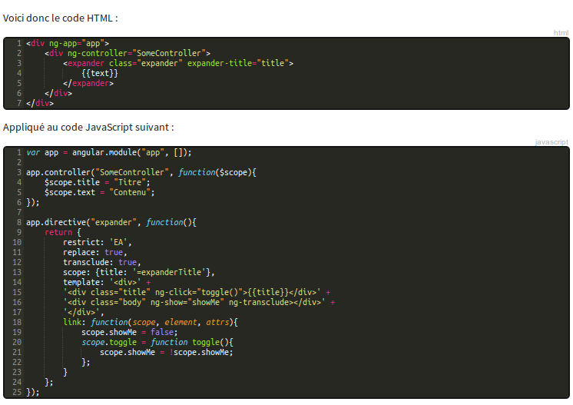
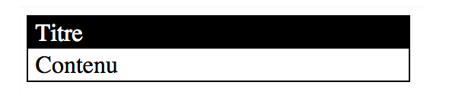
When you click on title, the contenu toggles.
Les options replace, transclude et template fonctionnent ensemble. Cela indique à Angular que nous souhaitons remplacer la déclaration de notre directive expander par notre template et que le contenu de notre balise expander (à savoir {{text}}) se trouvera à l'endroit où nous avons déclaré notre ng-transclude.
Replace is the action, template is the end output, transclude is what is going to be replaced.The scope we created applies only to that chunk of the html

Services
Services are used for routing mostly ($route, $http, $location). Services are considered as modules, and there are three types of these modules : Factory, Service (passed to the controller), Provider (the most customizable).
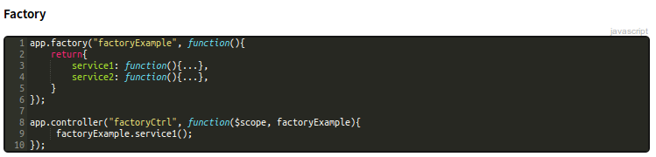
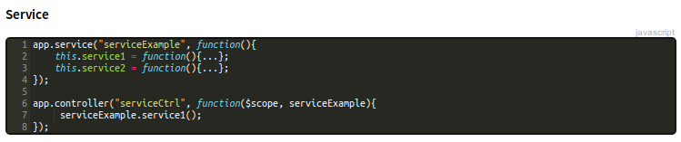
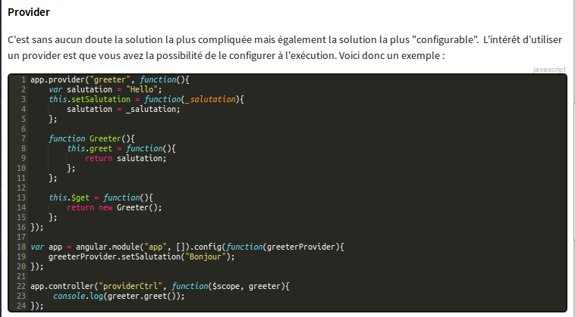
Most of the time, we'll user factroy.
Filters
These are modules that allow you to customize how you data is outputed.
{{ expression| filter }}
You can of course customize your own
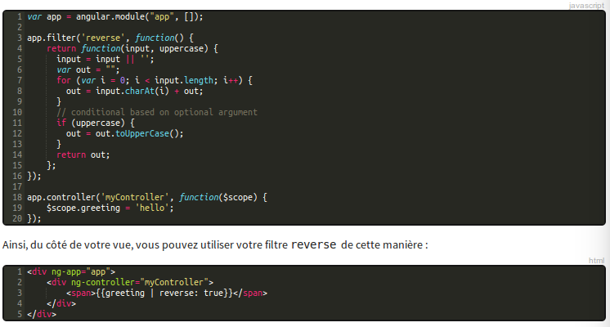
Routing
Angular doesnt manage routing natively, you need to use a angular-route.js module, which will be installed through the initial set up of your application.
Then we define our routing for the controllers in app.js.
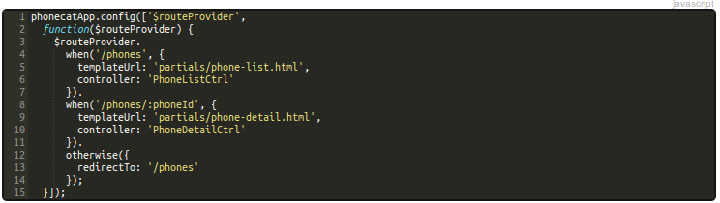
These routes all redirect to a template AND a controller. The controller will then fetch the data accordingly
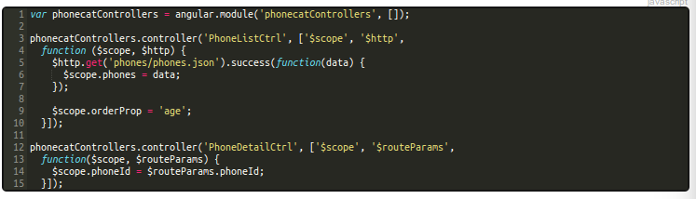
Testing
You can use Jasmine, which is a js framework, for testing.
http://jasmine.github.io/2.0/introduction.html
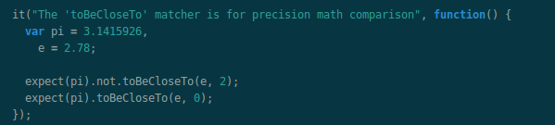
This will define a scope for testing. If in your code, at some point, the 'toBeCloseTo()' function, which you would have defined, would not output what it should, jasmine will tell.
A more concrete example :
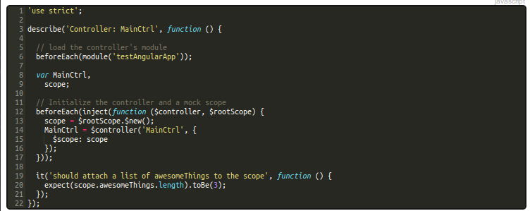
This spec has two phases : initialization and test
init phase : module() loads the app. Inject() injects mocks , test modules in your tests (that's why you init $scope tambièn).
Test phase : we test that awesomeThings table has 3 elements.
You need to define your own specs according to what you want to test and what output you are expecting.
Google uses minifiers. That's why their source code often has their variables being 'b', 'a', or other obscure names. To get around that, we can declare the second argument of the controller as being an array as such
the function parameters are scope and http, but they can be anything, because we declared $scope and $http before.

Easily implementing search queries
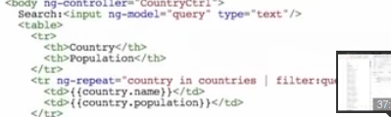

ng-model = 'query' implements the input search box
ng-repeat = 'country in countries | filter : query' tells angular where to filter
ng-repeat = 'country in countries | filter : query | orderby : population is an even better trick
ng-repeat = 'country in countries | filter : query | orderby : -population' filters by decreasing order by just adding a -

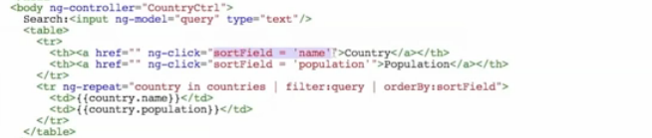
sortField allows to create a table with sorting buttons.
ng-click = 'sortField = 'name ; reverse =!reverse' makes it go both ways (reverse becomes !reverse with every click)
If you need to fetch json data in separate controllers, in order to do it once and store it, use a factory (services).
RESTful service with Angular
The controller code doesnt change at all. What changes is the ajax call, encapsulated in a factory.
Ng-repeat, ng-view, ng-app are directives, and you can create your own. This is considered to be the most powerful feature of angular, because it lets you define new html tags that have custom behaviour.

=> pusher. JS library that allows realtime communication with the server.

